useImperativeHandle:

🔗 Connect with Me:  
🌐 LinkedIn : https://www.linkedin.com/in/priya-bagde  
📂 GitHub : https://github.com/priya42bagde  
💻 LeetCode : https://leetcode.com/priya42bagde/  
🎥 YouTube Channel : https://youtube.com/channel/UCK1_Op30_pZ1zBs9l3HNyBw (Priya Frontend Vlogz)

* Data is passed **from parent to child components via props**, known as unidirectional data flow. **In this case, the parent component cannot access or call a function, or value from a child component directly** and sometime we want the parent component to reach down to the child component such as for **form validation or handling of user input**, to **get the data that originates in the child component for the reusability.** We can achieve through useImperativeHandle hook, which allows us **to expose a** **value, state, or function inside a child component to the parent component through ref**, which is giving the parent component **more control over** the child component and an **explicit way**.
* You can use when you need to **access a custom component’s internals in a way that is not possible using props**.
* Remember that **the ref object should be created in the parent component** **and passed to the child component using React.forwardRef.** useImperativeHandle must be **wrapped inside the forwardRef.**

**Syntax:** useImperativeHandle(ref, createHandle, [dependencies])

we can directly use useImperativeHandle **without constant**. We will use this hook **in the child class** because here **ref is passed down from the parent component and it should be created in the parent component.**, createHandle is a **variable or function name, or we can say data which we want to access in the parent component**. dependencies are the **array of dependencies that will occur to re-render.** **useImperativeHandle does not return anything.**

**Use cases:**

* When you need a **bidirectional data and logic flow**, but you don’t want to overcomplicate things by introducing state management libraries.
* You might programmatically **focus the first input field of a form as soon as a user lands on it, instead of having the user click into the form to focus** it.

**React.forwardRef**

* **React.forwardRef** allows you **to pass a ref from a parent component to a child component**, enabling you to **access and interact with the child component's DOM elements or instance methods**. This is particularly useful when you need **to control or manipulate elements or behaviors inside a child component directly from its parent component.**
* It allows you to create **higher-order components (HOCs) or wrapper components**, which **can accept a ref and pass it down to an underlying child component**.
* **useRef vs useImperativeHandle:** When compared to **useRef**, **useImperativeHandle** allows for more direct interaction with child components. You would use useRef if you only need **to access the state of the child component**, and you would use useImperativeHandle if you need **to interact with the child component in a more direct way.**

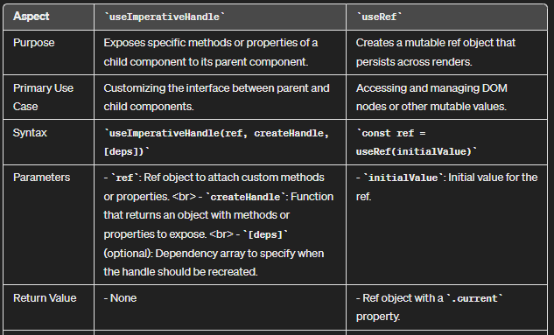

**Example:**

